**UAGC CST-499 Week 1 – Assignment – Github Account – Vicki Kelm**

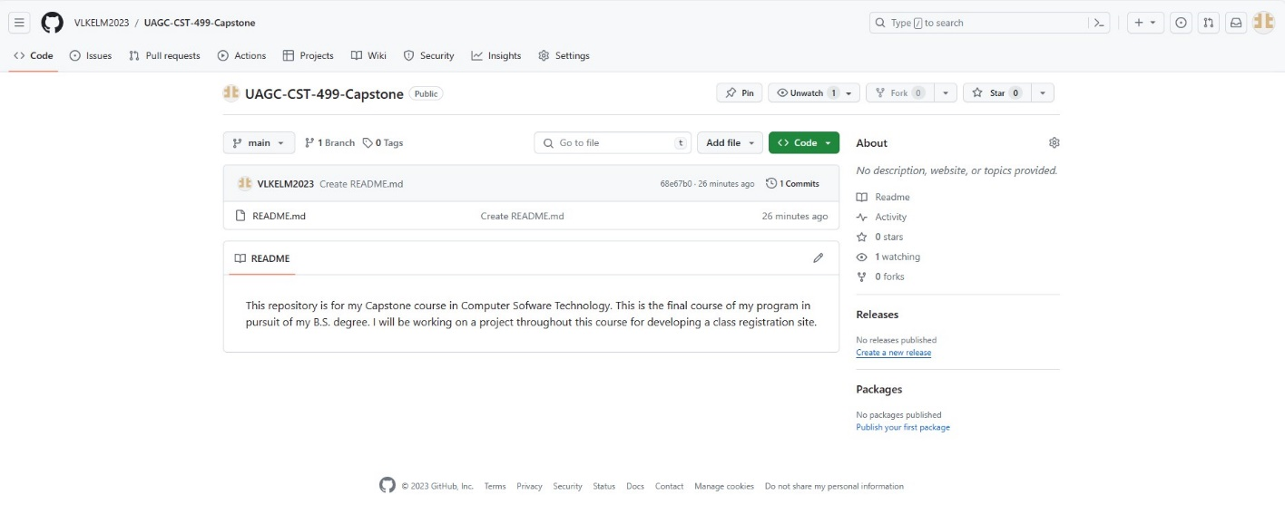

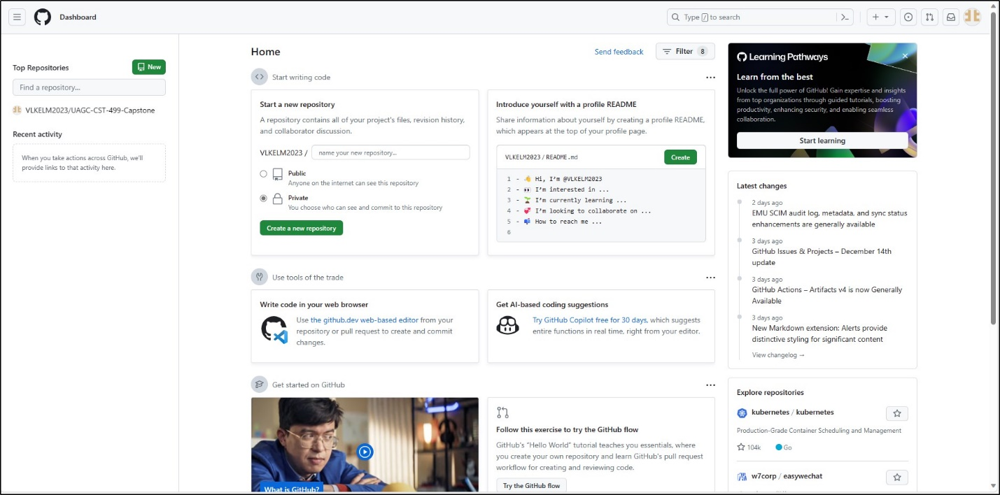

Link to Github Site: [VLKELM2023/UAGC-CST-499-Capstone (github.com)](https://github.com/VLKELM2023/UAGC-CST-499-Capstone)